**4- guess what is the number:**

**Below are the Steps of haw Algorithm working :**

* At first, the user enters a number between the two specified numbers 1&99.
* The compiler generates a random integer between the range and store it in a variable for future references.
* For repetitive guessing, a while loop will be initialized.
* If the user guessed a number which is greater than a randomly selected number, the user gets an output “*Try Again! You guessed too high*“.
* Else If the user guessed a number which is smaller than a randomly selected number, the user gets an output “*Try Again! You guessed too small”.*
* And if the user guessed in a minimum number of guesses, the user gets a “*Congratulations!* ” Output.
* Else if the user didn’t guess the integer in the minimum number of guesses, he/she will get “*Better Luck Next Time!*” output.

1:user input a randomly number .

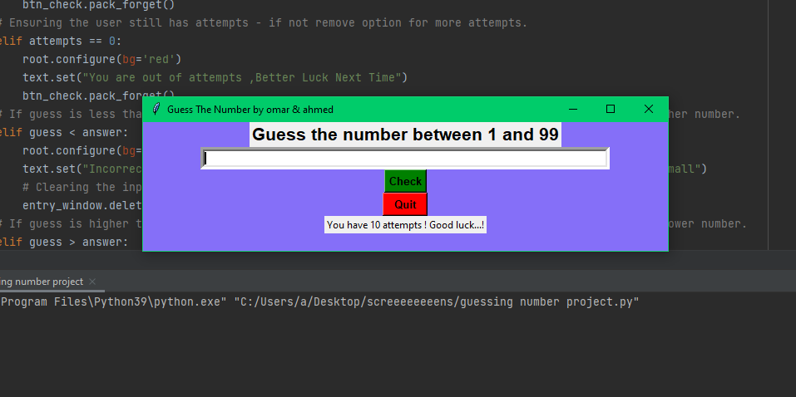

2: if the number is too high shows”you guessed too high”

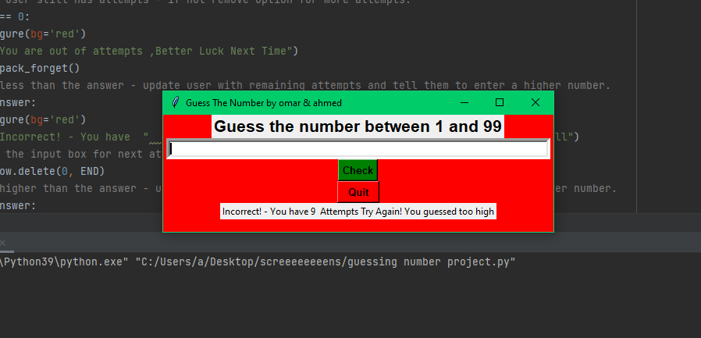

3:if the user guessed new number but it is too small shows “you guessed too small”

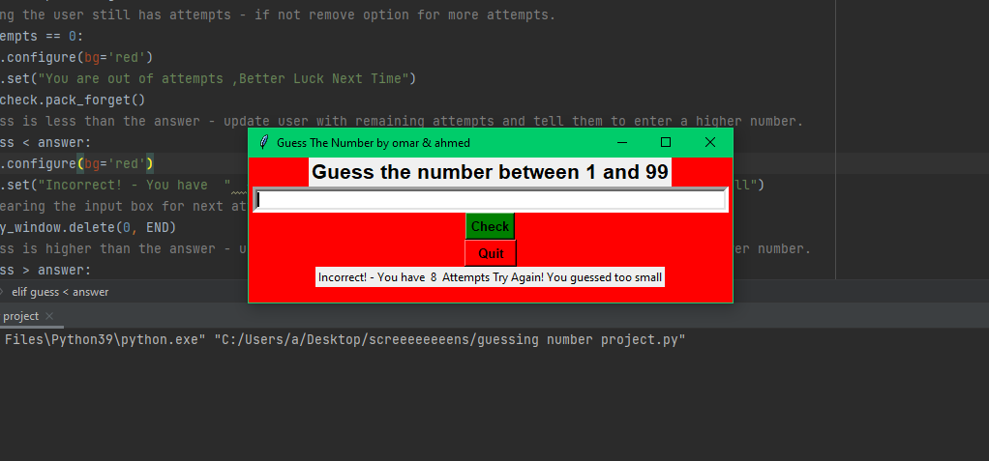

4: at the end when the user guessed correct number shows “you win”

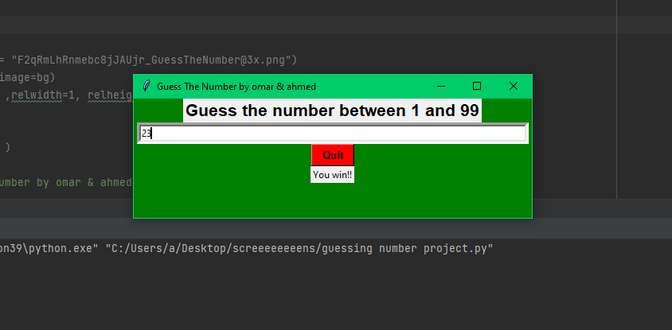

Source code :

import tkinter  
from tkinter import *  
import random  
  
# User have 10 chances  
chances = 10  
  
# Answer is randomly generated between 1 and 99  
answer = random.randint(1, 99)  
def check():  
 global chances  
 global text  
  
 # attempts is decreased by 1 to reflect users remaining attempts.  
 chances -= 1  
  
 # Getting users input  
 # int for converting it to integer data type  
 guess = int(entry_window.get())  
  
 # Comparing guess to answer  
 if answer == guess:  
 root.configure(bg='green')  
 text.set("You win!!")  
 btn_check.pack_forget()  
 # Ensuring the user still has attempts - if not remove option for more attempts.  
 elif chances == 0:  
 root.configure(bg='red')  
 text.set("You are out of attempts ,Better Luck Next Time")  
 btn_check.pack_forget()  
 # If guess is less than the answer - update user with remaining attempts and tell them to enter a higher number.  
 elif guess < answer:  
 root.configure(bg='red')  
 text.set("Incorrect! - You have " + str(chances) + " Attempts Try Again! You guessed too small")  
 # Clearing the input box for next attempt.  
 entry_window.delete(0, END)  
 # If guess is higher than the answer - update user with remaining attempts and tell them to enter a lower number.  
 elif guess > answer:  
 root.configure(bg='red')  
 text.set("Incorrect! - You have " + str(chances) + " Attempts Try Again! You guessed too high")  
 entry_window.delete(0, END)  
 return  
  
root = Tk()  
  
# bg = PhotoImage(file = "F2qRmLhRnmebc8jJAUjr_GuessTheNumber@3x.png")  
# label1 = Label(root, image=bg)  
# label1.place(x=0, y=0 ,relwidth=1, relheight=1)  
# frame  
# frame1 = Frame(root)  
# frame1.pack(pady = 20 )  
  
root.title("Guess The Number by omar & ahmed")  
# size of the window .  
root.geometry("500x150")  
root.configure(bg='#856ff8')  
# Label to instruct the user on what to do.  
label = Label(root, font='sans 16 bold',text="Guess the number between 0 and 100")  
label.pack()  
# User input box.  
entry_window = Entry(root, width=80, borderwidth=5)  
entry_window.pack()  
# Check button to find out if the entered amount is correct.  
btn_check = Button(root,font='sans 10 bold', bg='green', text="Check number", command=check)  
btn_check.pack()  
# Quit button so that the user can leave the game  
btn_quit = Button(root,font='sans 10 bold',bg='red', text=" Exit ", command=root.destroy)  
btn_quit.pack()  
  
# Creating a variable so we can update thr game progresses.  
text = StringVar()  
text.set("You have 10 chances ! Good luck...!")  
guess_chance = Label(root, textvariable=text)  
guess_chance.pack()  
  
# loop for the program  
root.mainloop()